# Web Fundamentals Lab

This document defines Lab assignment from the [“Web Fundamentals (HTML & CSS)“ Course @ SoftUni](https://softuni.bg/courses/web-fundamentals/). Please submit as homework a single zip / 7z archive holding the source code of all below described problems.

## HTML Structure

Create empty **HTML** **document**, called **index.html**. Create folder named “**styles”** and inside create **CSS file**, called “**style.css”**. In **HTML** document header create **Title** tag with content “**UEFA**” and link the **CSS** file.

In the **HTML** document body tag create the base document structure. Use semantic tags:

* Create **div** tag with **wrapper** id;
* Create **header** tag;
* Create **main** tag;
* Create **footer** tag;

In the **CSS** **file**:

* Set the **wrapper** margins to 10px from top and bottom and centered, width to 960px and height to 600px;
* Set the **header**: height – 100px;
* Set the **main** tag background color and height 500px;
* Set the **footer** height to 100px;



## Header

The **header** should contain **logo** and **navigation menu**.

* Insert “**uefa-logo.png**” as company logo in the top-left corner in a separate **div** tag;
  + The **logo should be a link** to the UEFA official site and link should open in new window/tab.
* Create **proper div for the navigation** containing **unordered list** with **4 elements**;

In the **CSS file** adjust the menu to look like the screenshot below:

* The menu’s elements should have **hover effect**;
* Use the **font “Arial”**  or any sans-serif font;

Home / UEFA Champions League / UEFA Europa League / Team of the year





## Footer

The **footer** should contain:

* **List with links**. Like the menu bar from header but with other style.
* A **paragraph** with copy rights.
* Social media links. You’ll be given a **sprite image** to use for social media **logos** and **their hover effects**.

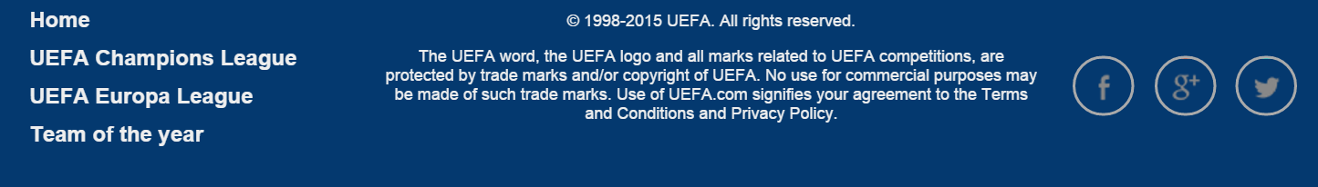

  

## Main

### Table

You should create a **table** with standings for a group **like the picture below**. The table should be in top left corner of the main. The background colors of rows are with decreased opacity.

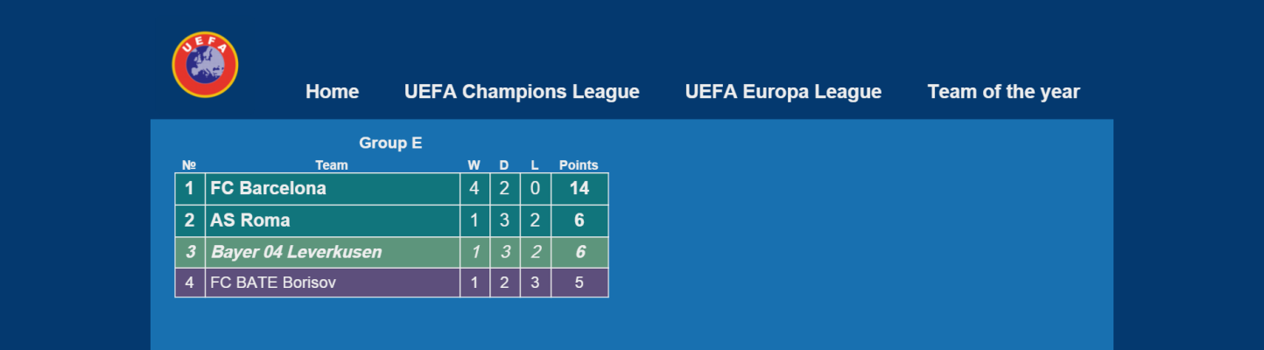

### Form

Next to the table you should create a **registration form** for sponsors. The **company name, password and confirm password** must be **required**.

Use proper input types.

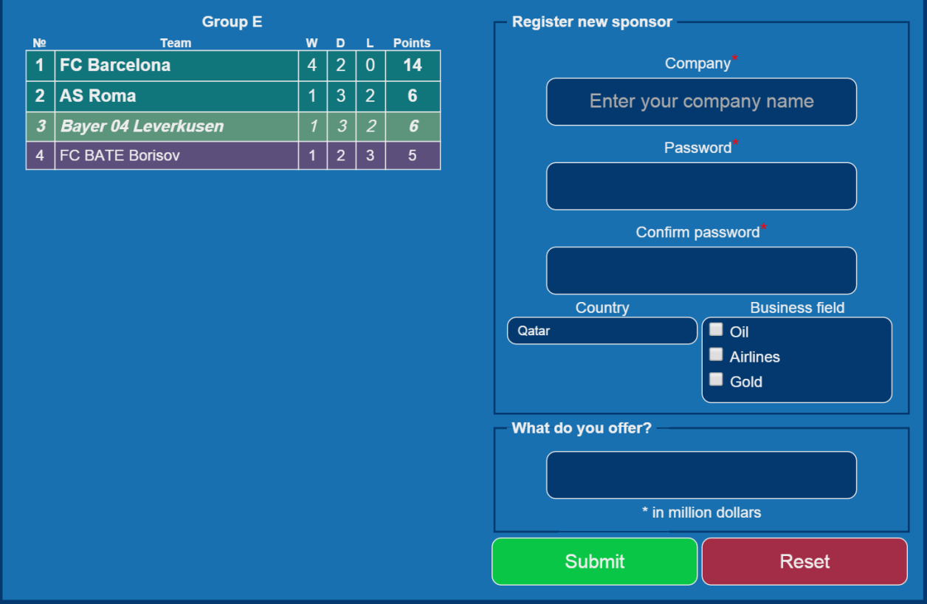

When “**Submit**” and “**Reset**” are clicked, they should change their colors.

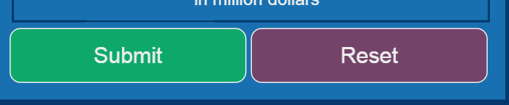

**HINT:** Use RGBA and just change their opacity.

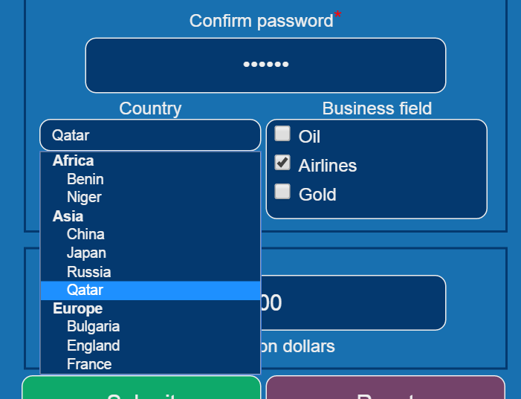

### Article

Under the table you should create an **article**. You’ll be given “text.txt”, pictures and font “PAC-FONT.TTF”. For article title use the Pacman font.

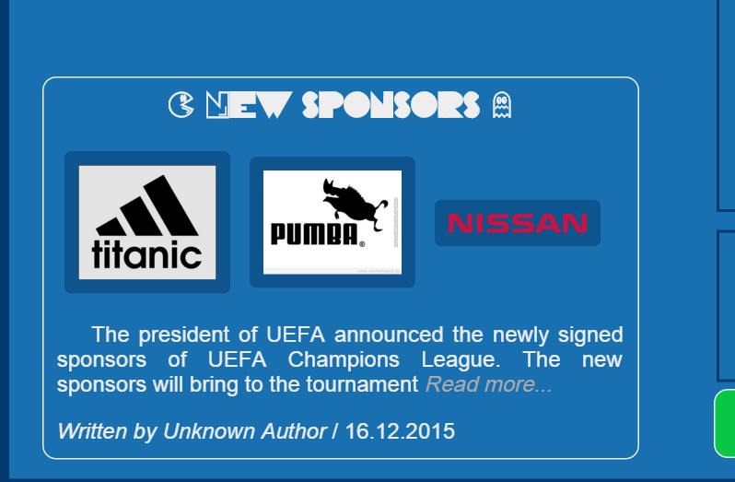

## *Create Drop-Down

Create a **drop down menu** for navigation item **“UEFA Champions League” in header when it is hovered**. It should contain: “Teams”, “Standings”, “Statistics”, “Finals” and “History” elements. **Drop down elements** should have **hover effect**.

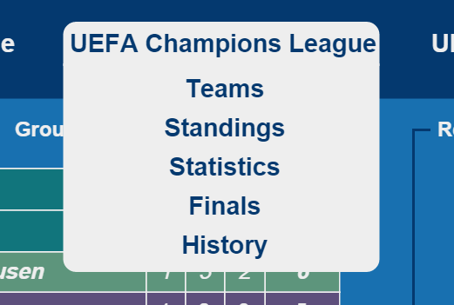 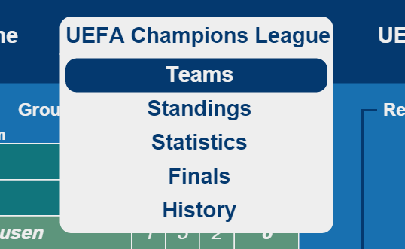

## Submit your solution

Submit an archive with your project as homework in the course instance.